SEE9-00000000

Title of the paper (20 words at most)
(Arial Black 16pt Bold)
Author¹*, Frederic Pellet² …
(Corresponding author is specified by a superscript asterisk (*), Font: Times New Roman 12pt Bold)
- Academic rank of author 1, affiliation, city, country (Times New Roman 10pt), e-mail address (Times New Roman 10pt Italic)
2. Professor, Geosciences and Geoengineering Dept., MINES Paris Tech, France
frederic.pellet@cfmr-roches.org
(SEE9 secretariat is only allowed to accept articles prepared based on this guideline)
The whole paper including Figures and Tables should not exceed 8 pages

Abstract (main title) (Font: Times New Roman 12pt Bold)
The paper should have an abstract of 100 to 150 words in the form of a paragraph, which independently expresses the topic, objectives, research method and summary of the results of the article. The abstract should not include tables, figures, equations and references. The font of the abstract and other text should be Times New Roman 11pt and the line spacing should be set to Exactly 16. The text of the abstract in the article file and in the registration process in SEE9 website should be the same.

Keywords: Between 4 and 6 words separated by commas and placed in one line (Font: Times New Roman 11pt).

1- Submit a Paper (main title) (Font: Times New Roman 12pt Bold)
The whole paper including Figures and Tables should not exceed eight pages. Please use MS Word version 2010 or later. The size of the paper is A4, single-column with margins of 25 mm from bottom, left and right and 30 mm from top. The fonts of the main titles should be Times New Roman 12pt Bold, the secondary titles Times New Roman 11pt Bold, and the text of the paper Times New Roman 11pt. The next-level titles should be listed by bullets. A space line is needed before each title. The first paragraph of the sections should be indented 6 mm. Please avoid footnotes.
When registering a paper in the conference system, it is necessary to prepare it based on this guideline and send the article file in both .doc and .pdf formats. Other formats or sending files by post or email will not be acceptable. Feel free to contact the conference secretariat at info@seeconferences.ir for any problem or question.

2- Paper Sections
A paper consists of these parts: Abstract, Keywords, Introduction, the main text, Results, Acknowledgement (optional) and References.

2-1- Introduction (Secondary title, Font: Times New Roman 11pt Bold)

2-2- Main Content

2-3- Equations, Figures and Tables

2-4- Results

2-5- Acknowledgment

2-6- References

3- Introduction
Introduction remarks the subject of the research and its literature. Also, the scientific and technical achievements of the research over other research should be clearly explained so that the novelty of the paper is clarified over other research.

4- Main Content
After the introduction, the main content of the article is presented in several sections, including the definition of initial concepts, planning the problem, and proposing the solution.

5- Equations, Figures and Tables
For equations, it is better to use the Equation tool in MS Word. The font is the same as the whole article but Italic. The number of the equation is in paranthesis placed at the most right hand side of the line. Consider the following example:
(1)
Regarding the figures, if they are not colored, prepare them in Grayscale, 300 dpi, and if they are colored, prepare them in RGB, 300 dpi, with layout feature of "In line with text", centered in an independent line. All figures and tables should be located in nearest place possible to where they are mentioned and numbered in the same order. If the figure is a chart, the quantity and unit of each axis is required. Figures caption is placed at the bottom and the Table caption at the top in Times New Roman 10pt Italic. If the figure or table is taken from another source, it should be cited. A space befor and after tables and figures are required. Consider the following example:
Table (1): Values of loss of individuals in USD based on income, education and age.
Uneducated | High school | Bachelor | M.Sc. and higher | Age
240000 | 384000 | 624000 | 1056000 | 25
210000 | 336000 | 546000 | 924000 | 30
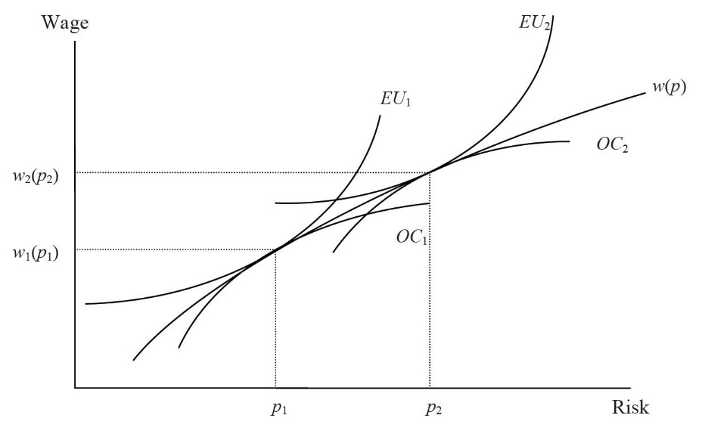
Figure (1): Worker's willingness to take risks and employer's willingness to pay for the same risks.

6- Results
In the Results section, the important points of the work should be summarized and the results are briefly explained. In this section, the scientific contribution of the article should be clearly stated. Never repeat the Abstract section here. The result can refer to the applications of the research performed, present new and vaguely researched points, or propose the expansion of the discussion to other areas.

7- Acknowledgment
The acknowledgment section, if needed, is shortly prepared in a paragraph in which individuals or organizations who have somehow assisted in the preparation of the article are mentioned. The existence of this section is optional.

8- References
The last part of the paper is its References. All references should be used and cited at least once in the article. Choose the APA style for references (for your convenience, you may use the link www.scribbr.com/citation/generator/apa). The font is Times New Roman 10pt. Every reference has a 6 pt distance with the next one. Examples:

Askari, F. (2013). Seismic three-dimensional stability of reinforced slopes. Journal of Seismology and Earthquake Engineering, 15(2), 111-119.
Clough, R.W. & Penzien, J. (1975). Dynamics of Structures. Tokyo: Mc Graw-Hill Kogakusha.
Motamed, H. (2012). Determination of Indices and Criteria of Urban Seismic Safety against Earthquake. Ph.D. Dissertation. International Institute of Earthquake Engineering and Seismology, Tehran, Iran.

